Verification Steps for Curve Number Generator App Results
This document provides the recommended process for verifying the accuracy of Curve Number (CN) values generated by the Curve Number Generator App. The goal is to ensure that the app’s results align with manually determined CN values based on the same soil and land use inputs.
Step 1: Prepare GIS Layers
- Add the required soil type and land use shapefiles to a GIS project.
- Download the generated CN polygons from the Curve Number Generator App (in .gpkg format) and add them to the same GIS project.
Step 2: Create Test Points
- Generate a set of scattered points across the area of interest. These points will serve as verification samples.
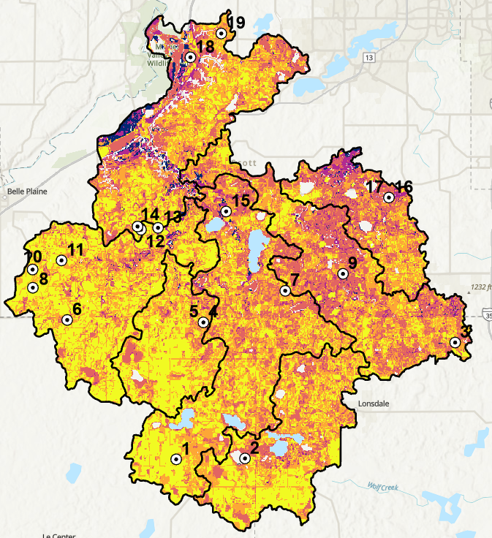
Step 3: Run Intersect Analysis
- Use the GIS software’s Intersect function to combine the created test points with the soil layer, land use layer, and the generated CN polygons.
- The resulting layer should include all necessary attributes (e.g., soil hydrologic group, land use code, CN value from the app).
Step 4: Export and Clean the Attribute Table
- Export the attribute table from the intersect layer to Excel.
- Remove unnecessary columns and keep only:
  - Soil Hydrologic Group
  - Land Use Code
  - CN value generated by the app
Step 5: Manually Assign CN Values
- Add a new column in Excel and manually determine the CN value for each point using the lookup table applied in the app.
- This manual step ensures the calculation process aligns with established CN tables.
Step 6: Compare and Verify
- Compare the manually assigned CN values against the app-generated CN values.
- If the two values match for all test points, the verification is successful and the analysis passes.
- Any discrepancies should be reviewed to identify possible data/input or app issues.

